United States Department of the Interior
National Park Service
National Register of Historic Places Registration Form

This form is for use in nominating or requesting determinations for individual properties and districts. See instructions in National Register Bulletin, How to Complete the National Register of Historic Places Registration Form. If any item does not apply to the property being documented, enter "N/A" for "not applicable." For functions, architectural classification, materials, and areas of significance, enter only categories and subcategories from the instructions.

- Name of Property
Historic name: _Prospect A.M.E. Church _________
Other names/site number: __S11395______________________________
Name of related multiple property listing:
___________________________________________________________
(Enter "N/A" if property is not part of a multiple property listing
____________________________________________________________________________
- Location
Street & number: _220 South Railroad Avenue ______________________
City or town: _Georgetown_______ State: _DE___________ County: _Sussex______
Not For Publication: Vicinity:
X

____________________________________________________________________________
- State/Federal Agency Certification
As the designated authority under the National Historic Preservation Act, as amended,
I hereby certify that this nomination ___ request for determination of eligibility meets the documentation standards for registering properties in the National Register of Historic Places and meets the procedural and professional requirements set forth in 36 CFR Part 60.
In my opinion, the property ___ meets ___ does not meet the National Register Criteria. I recommend that this property be considered significant at the following
level(s) of significance:
___national ___statewide _X_local
Applicable National Register Criteria:
_X_A ___B ___C ___D

Signature of certifying official/Title: Date
______________________________________________
State or Federal agency/bureau or Tribal Government

In my opinion, the property meets does not meet the National Register criteria.

Signature of commenting official: Date

Title : State or Federal agency/bureau
or Tribal Government

____________________________________________________________________________
- National Park Service Certification
I hereby certify that this property is:
entered in the National Register
determined eligible for the National Register
determined not eligible for the National Register
removed from the National Register
other (explain:) _____________________

______________________________________________________________________
Signature of the Keeper Date of Action

____________________________________________________________________________
- Classification
Ownership of Property
(Check as many boxes as apply.)
Private:
X

Public – Local

Public – State

Public – Federal

Category of Property
(Check only one box.)
X
Building(s)

District

Site

Structure

Object

Number of Resources within Property
(Do not include previously listed resources in the count)
Contributing Noncontributing
____1________ _____________ buildings

____1________ _____________ sites

_____________ _____________ structures

_____________ _____________ objects

____2________ ______________ Total

Number of contributing resources previously listed in the National Register __0______
____________________________________________________________________________
- Function or Use
Historic Functions
(Enter categories from instructions.)
Religion: Religious facility: Church
___________________
___________________
___________________
___________________
___________________
___________________

Current Functions
(Enter categories from instructions.)
Religion: Religious facility: Church
___________________
___________________
___________________
______________________________________________________________________
- Description

Architectural Classification
(Enter categories from instructions.)
Other (vernacular house of worship)
___________________
___________________
___________________
___________________
___________________
___________________

Materials: (enter categories from instructions.)
Principal exterior materials of the property: _Brick and cement block foundation, wood, synthetic cladding and roofing____________

Narrative Description
(Describe the historic and current physical appearance and condition of the property. Describe contributing and noncontributing resources if applicable. Begin with a summary paragraph that briefly describes the general characteristics of the property, such as its location, type, style, method of construction, setting, size, and significant features. Indicate whether the property has historic integrity.)
______________________________________________________________________________
Summary Paragraph
Prospect A.M.E. Church, located at 220 South Railroad Avenue, is a small frame rectangular church originally constructed c. 1866 on the outskirts of Georgetown, Delaware. Situated within a hundred feet of the Delaware Maryland and Virginia Railroad and its branches, later known as the Lewes Branch and the Franklin City Branch, this Church became the center of the African American community, sometimes referred to as African Row, which evolved around it during the late-nineteenth and early-twentieth centuries. Though enlarged to meet the needs of its congregation overtime, it survives as a building of great local significance. Not only was Prospect A.M.E. Church the only African American Church in the Georgetown vicinity for decades but its church history notes that this house of worship also functioned as a school for African American students during the late-nineteenth century. Rich in local history, perhaps Prospect A.M.E. Church’s local level of significance is best defined by Church historian Rev. Gerald William Scott who wrote “the church by the railroad tracks, has served as a lighthouse throughout the community of Georgetown, leading men and women, boys, and girls from the turbulent rocks along the stormy seas of life, to the calming and restful shores where Jesus lovingly awaits. This is our heritage, and this will forever be our legacy.” This historic church is also the last-known historic surviving public property within its immediate vicinity.
______________________________________________________________________________
Narrative Description
Exterior Description
Located at the southeast corner of East Adams Street and South Railroad Avenue, cornerstones positioned on the northeast corner of the church denote the date of construction as well as dates for modifications made during the ministry of two pastors – M.E. Harmon (1956) and J.W. Smith (1973) (Figure 10). However, the church retains its original 22’ X 38’ nineteenth-century core. Its foundation consists of a combination of bricks and cement blocks. In 2014 church trustees raised money to install a new asphalt shingled roof.

A photograph taken by Delaware historian Frank Zebley between 1936 and 1939 (Figure 5) shows the building with its original white painted clapboards and contrasting painted corner posts as well as a centrally placed one-bay wide frame vestibule on the center of the gabled façade. This small, framed vestibule was removed and replaced by a larger vestibule spanning the gable end façade. Lancet-shaped two-over-two double hung windows, flank each side of the one-bay vestibule and a window is positioned above the vestibule in the apex. An undated photograph, probably taken after the 1956 renovation, shows that the church covered with white asbestos shingles and smaller two-over-two double hung sash windows on northern and southern elevations (Figure 6). After the 1973 renovations, aluminum siding was installed over the entire building covering earlier building materials. The unusually large fenestration for multi-paned, double-hung sash windows featured in the 1930s photographs, no longer exist. New wooden two-over-two double hung sash windows are featured on the side walls of the sanctuary. Four of these windows are symmetrically placed on the northeast side of the church and three on the southwest elevation. One former window on the southeastern elevation was recently converted into a door in order to accommodate parishioners using the handicap ramp. By 1973, the remodeled church featured a small one-story choir box addition on the southwest gable end, a one-bay wide office added to the southwest gable corner of the church, and a three-bay vestibule with a center double door entrance flanked by lancet-shaped windows probably salvaged from the earlier vestibule spanning the main gable end façade. Though the first-floor level of the façade vestibule is sheathed with aluminum siding, the apse is shingled. A more recent enhancement includes the installation of a concrete handicap ramp with wooden handrail along the southeast elevation.

Interior Description
The historic spatial arrangement of the sanctuary remains intact; a center aisle configuration flanked by rows of pine pews with incised crosses on end pieces. The altar, separated from the sanctuary by a communion rail, contains a free-standing wooden altar inscribed with the words “IN REMEMBRANCE OF ME,” a free-standing wooden pulpit, a modern-designed baptismal font, three wooden armed chairs with upholstered seats and backs behind which is a knotty-pine divider separating the choir box from the altar area. Knotty-pine wainscoting, characteristic of the 1950s era, adorns the walls within the sanctuary and choir box. The three chairs behind the altar are reserved for the Minister, the Elder, the Bishop or other church official.

Recent removal of several floorboards for access to the foundation from the sanctuary have uncovered evidence of reused construction materials. What were once hand-hewn, beaded rafters are now used as floor joists to support the floor of the sanctuary. The reuse and repurpose of materials contribute to common building tradition in Delaware, speaking to the vernacular style of the church.

The Cemetery
The historic cemetery features irregularly placed gravestones and contains a combination of both marked and unmarked burials. Local Church historians believe that burials from the 1830’s remain on the premises, perhaps within the overgrown wooded area situated at the southwest corner of church property. Gravestones represent a variety of styles including oval topped markers and obelisks. Iconography includes lambs as well as clasped hands. Readable gravestones, ranging in dates from the 1890s through the early-twentieth century, represent a number of prominent Georgetown African American families including Bradley, Hopkins, Ingram, Mitchell, Pettyjohn, Willey, Woolfred, and Warrington. There are at least 27 known interred individuals in the cemetery.

Information about the rise of social status representing individuals associated with Prospect A.M.E. Church are indicated by samples of social column entries extracted from The Milford Chronicle newspaper (Figure 7). Phrases such as “a highly respected colored man,” “Highly respected resident of this town,” “highly respected colored woman,” and “a prominent colored citizen of this town” denote individuals of accomplishment. Sample obituaries from 1928 to 1931 provide additional information about Georgetown residents associated with Prospect A.M.E. Church including names of a Civil War veteran, a railroad man, individuals residing in close proximity to the church, a man whose wife was a local schoolteacher, and a locally employed individual. According to their obituaries, services for these deceased individuals were held at Prospect A.M.E. Church and their remains were either interred in the adjoining cemetery or at another location. Such entries also noted names of the reverends officiating services as well as funeral directors. Announcement of church activities also appeared in the social columns under the “Georgetown” heading such as an announcement regarding the celebration of the October Rally Day in 1921 (an annual fall event) and an announcement advertising preaching of Rev. Garfield McDowell in 1931 (Figure 8).

Qualities of Integrity
Prospect A.M.E. Church underwent modifications in the twentieth century to best meet the needs of the congregation that are not reflective of workmanship and design as defined by the National Park Service. However, Prospect A.M.E. Church possesses four levels of historic integrity relevant to the nomination’s period of significance – 1866 to 1956.

Location: Prospect A.M.E. Church and Cemetery remains on the tract of land conveyed to trustees of the church by for the construction of a church and establishment of a cemetery in 1840.

Feeling: Prospect A.M.E. Church continues to evoke a feeling of reverence as a house of worship which remains in continuous use. This historic church is in the First Episcopal District of the African Methodist Episcopal Church which contains seven conferences and covers the Northeast Corridor of the United States and Bermuda.

Association: Prospect A.M.E. Church possesses a rich history. This church and its congregation represent the continuation of Richard Allen’s establishment of the African Methodist Episcopal Church in 1794, Georgetown’s first African American Church, as well as the development of Methodism in Sussex County, Delaware. Unlike other African American churches in Sussex County, Prospect A.M.E. Church possess an unusual status for its association with the education of African Americans within the Georgetown area during the nineteenth century and was the first and only school for African American children, offered a Sabbath School to a broader number of students.

Setting: Though originally constructed within a rural area outside of the boundaries for Georgetown, Delaware, this historic church became part of the incorporated community in 1863.The church and its cemetery, which ceased the practice of interring individuals during the mid-twentieth century, is situated within 150 yards of active railroad spurs and nearby vacant commercial/industrial facilities situated on the south side of the railroad spur locally known as the Franklin City Branch. This vacant industrial complex site recently contained a waste management commercial facility. Historically, this site contained a late-nineteenth century manufacturing complex identified as the Sussex Manufacturing Company – manufactures of sawed pine lumber, shingles, lath, packing boxes and general cooperage on the Georgetown 1885 Birds Eye View (Figure 3). Because of the manufacturing company’s close proximity to Prospect A.M.E. Church, it is plausible to assume that perhaps the congregation may have obtained construction materials from that local manufacturing facility.

________________________________________________________________
- Statement of Significance

Applicable National Register Criteria
(Mark "x" in one or more boxes for the criteria qualifying the property for National Register
listing.)

- Property is associated with events that have made a significant contribution to the broad patterns of our history.

X
- Property is associated with the lives of persons significant in our past.
- Property embodies the distinctive characteristics of a type, period, or method of construction or represents the work of a master, or possesses high artistic values, or represents a significant and distinguishable entity whose components lack individual distinction.

- Property has yielded, or is likely to yield, information important in prehistory or history.

Criteria Considerations
(Mark “x” in all the boxes that apply.)
X
- Owned by a religious institution or used for religious purposes

- Removed from its original location

- A birthplace or grave

- A cemetery
- A reconstructed building, object, or structure

- A commemorative property

- Less than 50 years old or achieving significance within the past 50 years

Areas of Significance
(Enter categories from instructions.)
Ethnic Heritage: Black
Social History _______
Religion ___________
___________________
___________________
___________________
___________________

Period of Significance
1866-1956__________
___________________
___________________

Significant Dates
1866 (date of construction)
1956 (date of last major renovations to the original section)
___________________

Significant Person
(Complete only if Criterion B is marked above.)
___________________
___________________
___________________

Cultural Affiliation
African Methodist Episcopal (A.M.E.) Church______
___________________
___________________

Architect/Builder
___________________
___________________
___________________

Statement of Significance Summary Paragraph (Provide a summary paragraph that includes level of significance, applicable criteria, justification for the period of significance, and any applicable criteria considerations.)
Prospect African Methodist Episcopal (A.M.E) Church is significant for listing in the National Register of Historic Places at the local level under Criterion A under Social History, Ethnic Heritage: Black, and Religion. Constructed during the Reconstruction Era in 1866, this church has continuously served the African American Community in Georgetown, Delaware for over 150 years. In support of Criterion Consideration A, the church functioned as a focal point within the African American community of Georgetown by fulfilling the community’s religious and social needs. According to J. Thomas Scharf’s History of Delaware published in 1888, the forty-member congregation allowed their sanctuary, situated within the center section of the existing church, to be used for meetings as well as a school. The period of significance,1866 to 1956, represents the construction date of the main portion of the church and the last major interior remodeling campaign which concluded in 1956.
______________________________________________________________________________
Narrative Statement of Significance (Provide at least one paragraph for each area of significance.)

Supportive Documentation for Criterion A:
The local level of Social History, Ethnic Heritage: Black, and Religion for Prospect A.M. E. Church is best conveyed by a review of the limited existing documentation including deeds, historic maps, Richard Allen’s Autobiography (published post-mortem in 1833), published history books, and articles featured in The Christian Recorder (a weekly newspaper published by the African American Methodist Episcopal Church beginning in1852 which concentrated on religion, morality, science, and literature), and U.S. census records.

Early A.M.E. Activities in Georgetown
Lewis and Moses Robinson, who in 1839 became founding Trustees of Prospect A.M.E. Church in Georgetown, were early A.M.E. ministers in Sussex County. According to local historian Russell C. McCabe, by the 1830’s a “circuit” of A.M.E. congregations was established in Sussex County. It is during this period that information confirming Moses Robinson as an elder and minister of the church first appears. An 1837 article published in The Colored American newspaper included a list of churches in the A.M.E. [Lewestown Circuit]. Locations included the Sussex County towns of Lewes, Slaughter Neck, Milton, Indian River, Laurel, Dagsboro, and Georgetown. According to nineteenth century publications, churches within this circuit were served by two ministers namely Peter Lewis and Moses Robinson. It is interesting to note that the aforementioned article documents the existence of the Prospect A.M.E. congregation before the purchase of land for a church.

Other period evidence documenting Lewis’ and Robinson’s activity in Sussex County includes an October 1839 Sussex County indictment against them for “Continuing Meeting after Ten O’clock,” reflecting laws restricting African American activity put in place after the 1831 Nat Turner slave revolt in Virginia. In the State of Delaware vs. Jacob Tingle, Henry Tingle, Charles Ingram, Peter Lewis, Moses Robinson, Elisha [Sockom], and Plemouth Bounds, the defendants plead and were found “Not Guilty” in a trial by jury. Of the six African American defendants, at least half, Henry Tingle, Peter Lewis, and Moses Robinson, owned land. Henry Tingle resided in Delaware for the entirety of his adult life. In the 1860 U.S. Federal Population Census, Tingle is listed as a ship carpenter with a real estate value of $750 and personal estate value of $100. In the 1870 U.S. Federal Population Census for Dagsboro Hundred, Tingle is listed as head of household and occupation of ship carpenter, with a personal estate value of $100 and real estate value of $300. In the 1880 U.S. Census, Tingle is the head of household and a ship carpenter by trade. Tingle resided in Milton, Delaware, at the time of his death and was listed a carpenter by trade. Charles Ingram, resided in Dagsboro Hundred for his adult life, does not appear to have owned land. In the 1850 U.S. Federal Population Census, Ingram was listed as a farmer in Dagsboro Hundred. In the 1860 U.S. Federal Population Census, Ingram does not have an occupation listed and does not have real estate or personal estate valued. In the 1870 U.S. Federal Population Census, Ingram is listed as “at home” within Dagsboro Hundred. Note, Dagsboro Hundred, a political subdivision, adjoins Georgetown Hundred’s southern boundary.

To meet the needs of increased attendance within the A.M.E. religion, Prospect A.M.E. Church was constructed in between 1866 and 1867, being one of three A.M.E. churches constructed within Sussex County during this timeframe.

By 1885, a “Georgetown Circuit” had been established and was led by Prospect A.M.E. Church and included Dickerson Chapel in Millsboro, and Antioch in Frankford. In an 1885 deed, Trustees of three local A.M.E. Churches (Prospect in Georgetown, Bethel in Millsboro, and Antioch in Dagsboro) listed as: Robert Woolford, Silas Little, Basha Bradley, Wright [Hensel], Isaac Hall, George Woolford, John Street, W. Ingram, Harry Ingram, Noah W. Moore, John C. Robert, Riley Robert, Abraham Ingram, and George Ingram purchased a lot with dwelling from Thomas W. Hatfield for $75 for use as a shared parsonage. The parsonage’s location in Georgetown, though no longer standing on the premises, illustrates Prospect A.M.E. Church’s relevance in the center of the Georgetown Circuit, due to its physical proximity to the parsonage.

In addition to sharing their ministers with other A.M.E. churches throughout Sussex County, Prospect A.M.E. Church in Georgetown and St. George A.M.E. Church in Lewes have other similarities, including records of activity and a congregation dating back to the 1830s if not earlier, and the construction of formal church structures following the Civil War. Based on archival evidence presented through deeds and newspaper articles, it is clear A.M.E. churches throughout Sussex County worked together to provide opportunities and advocate for the advancement of African Americans in the post-Civil War Reconstruction Era (Figure 8).

Members of Prospect A.M.E.
Congregational members of Prospect A.M.E. Church were known throughout the wider Sussex County community in large part due to their prominent roles within the community. The Milford Chronicle, a local twentieth century newspaper, reported on the deaths of well-known African Americans, noting services and interment, taking place at Prospect A.M.E. Church (Figure 8).

Prospect A.M.E. Church extended its arms into the greater community by advertising service dates and times along with special events. Of particular note, is the annual Rally Day celebration, hosted by Prospect A.M.E. Church during the first half of the twentieth century. Rally Day was established in part to encourage children and adults alike to embrace and engage in Christian education activities (Figure 8).

John Pettyjohn, interred in Prospect A.M.E. Church’s cemetery, resided in Georgetown Hundred and attended services at Prospect A.M.E. Church. Pettyjohn is enumerated in the 1900 U.S. Federal Census as a waiter in a hotel, owning his own home. In the 1910 Census, Pettyjohn continues his occupation as a waiter, residing with his daughter and her family on Railroad Avenue in Georgetown. Given Pettyjohn’s residence on Railroad Avenue, it is likely he lived in close proximity to Prospect A.M.E. Church, within the historic African Row neighborhood.

John Woolford, noted as a Trustee of Prospect A.M.E. Church in 1885, was enumerated in the 1870 U.S. Federal Population Census as a sailor in Georgetown Hundred.

Prospect A.M.E. Church: The First School for African American Children in Georgetown, Delaware
The A.M.E. denomination led early efforts to educate African Americans. The sanctuary of Prospect A.M.E. Church, in keeping with this trend, functioned as a school for local African American students beginning in 1866 and was still functioning as such by 1888. An earlier church, built by congregational members on this property, may have been the site of the following incident which occurred in 1848. The earlier church not being located within the corporate limits of Georgetown and would have been considered “near Georgetown:”

We learn that a few months ago, a colored man who had received some education, commenced teaching a school for free colored children, near Georgetown, Sussex county, Del., when a number of white rowdies, went to the school master and threatened him that they would take him to the public “whipping post,” if he did not cease teaching his school; the man remonstrated, stating that it was a lawful calling, and he was not willing to abandon it, however, in a few days these rowdies went to the school-house, took the teacher out of the school, carried him to the public “whipping post” at Georgetown, and unmercifully lacerated the poor fellow’s back, and only let him escape upon promise to teach no more.

As Georgetown’s oldest African American congregation, members believed that it was important to provide instruction despite opposition expressed throughout the nineteenth century as noted in the following newspaper quote:

Keep the people in ignorance, lest they attain knowledge of their rights; withhold from them instructions, lest they become dissatisfied with government.

Though racial tensions existed in the State in the early part of the nineteenth century, African American and white children were occasionally educated alongside each other. Thirteen years after the American Watchman article was published, Delaware’s General Assembly passed the Free School Act of 1829 which legally excluded colored children:

…it was not uncommon for colored children . . . to be admitted to the ordinary schools of the state . . . since the passage of that law, which gave a legal sanction to the exclusion of colored children, the appearance of one of them in a school of white children is an unusual phenomenon.

As a result, of the passage of this law religious organizations enhanced their efforts to educate Delaware’s African American students. According to the records of Methodist Episcopal Reverend William Yates, 187 black students attended schools offered by religious organizations in 1850, and 250 attended in 1860.

Documentation suggests that the school at Prospect A.M.E. Church, constructed in 1867 a year after the Delaware Conference of the Methodist Episcopal Church passed its resolution to stress education, was still functioning in 1888.

The Delaware Conference of the Methodist Episcopal Church passed a resolution at their annual meeting in 1866 that recommended to ministers that they should stress in their sermons “the vital importance of education, as being the great lever in elevating our race.” Thus, from the beginning, church and school in the African American community were inseparable, and the Methodist Episcopal Church took a strong position in support of education.

The location of a school for black children within Prospect A.M.E. Church reflects the A.M.E. Church’s theological emphasis on earthly solutions to the social and political injustices faced by black people. In fact, Richard Allen, the founder of the AME Church, split with the traditional Methodist church because of its refusal to apply that aspect of Christian theology to the suffering of black people. While late eighteenth-century Methodism condemned slavery, early nineteenth-century Methodism acquiesced to the racial attitudes of that time, adopting segregated services, and denying free black members, let alone those who were enslaved, full participation.

At that time, on throughout the twentieth century into the present day, education has been seen as a way to uplift people. In 1816, in a “Reply to ‘Thoughts on the subject of educating Negroes in the United States’,” the Dover newspaper American Watchman said, “Religion and Civilization, the grand restorers of man to his pristine state, have uniformly been accompanied by some degree of education.” Arguing that education would uplift black people from their present condition which was “not the effect of natural, but artificial causes” the author went on to draw the conclusion quoted at the top of this essay: “Keep the people in ignorance, lest they attain knowledge of their rights; withhold from them instructions, lest they become dissatisfied with government.” In this thinking, which informed Richard Allen’s A.M.E. theology, we see the philosophical underpinnings of the American Revolution inspired by the European Enlightenment interpreted uniquely within Methodism and more broadly within a religious movement called the Great Awakening. Access to quality education was a fundamental pillar of success in the A.M.E. Church. In the Reconstruction Era, the A.M.E. church worked to attract skillful teachers to educate African American children. Specifically in Georgetown, the congregation at Prospect took special interest to ensure educational salaries were competitive enough to draw quality educators to the town.

While 1866 is the year of the earliest cornerstone of the present Prospect A.M.E. Church, the church’s historic marker cites an earlier “original structure” that was replaced by the present church. 1839 is the year “William E. Harris of Georgetown signed a bond conveying 2 acres and 20 square perches of land to Moses Robinson, Timothy Jacobs, George Ratcliff, Curtis Jacobs, and Isaac Waples, ‘Trustees of the African Methodist Episcopal Church at or near Georgetown,’ to be used as a site for a church and cemetery. The present church still stands there.”

From 1866 until 1870 the school at Prospect A.M.E. Church was financed by the Freedmen’s Bureau, established by an Act of Congress at the end of the Civil War as a “Bureau for the Relief of Freedman and Refugees to provide food, shelter, clothing, medical services, and land to displaced Southerners including newly freed African Americans.” The Bureau was also responsible for setting up schools “during the present war of rebellion, and for one year thereafter.”

After 1870, students began paying tuition, with supplemental funds coming from the Delaware Association for the Moral Improvement and Education of Colored People. The Association was led by Bishop Alfred Lee of the Episcopal Church of Wilmington. The support the association provided combined local resources with those from the American Freedman’s Union Commission, and the Army Bureau of refugees, Freedman, and Abandoned Lands (also called “The Freedman’s Bureau”). The Delaware Association for the Moral Improvement and Education of Colored People helped Black communities establish schools throughout the state.

According to the listed Richard Allen School National Register nomination Georgetown was among the first to receive assistance from the Delaware Association for the Moral Improvement and Education of the Colored People. The school for African American children was placed at Prospect A.M.E. Church and identified as Progress School and assigned the number twelve.

The June 1, 1867, minutes of the Acting Committee of the Delaware Association for the Moral Improvement and Education of the Colored People describe “On Sunday and Monday last, the teacher at Georgetown, Sarah A. Owens, was mobbed and driven from the place.” Joseph A. Thompson replaced Owens on June 21st. He was a graduate of the Lincoln Institute in Oxford, Pennsylvania. Emma L. Davis taught there between 1868-69. She described unfavorable public sentiment toward the school in her monthly reports. Mary L. Boyer was the next teacher. She had twenty-nine students, each of whom paid a fee to support her room and board. According to the teachers’ monthly reports, Prospect A.M.E. Church also hosted a Sabbath School taught by community members and open to a broader number of students than the regular school.

The Development of the Town of Georgetown
The Town of Georgetown was established as the County Seat of Sussex County, Delaware in 1791 after the Delaware Assembly enacted legislation authorizing the relocation of the county seat from Lewes to a more central location within the county. A 100-acre tract known as “James Pettijohn’s Old Field” was selected with one acre reserved for the construction of a courthouse and the remaining property laid out for building lots. The new town was named in honor of George Mitchell, an influential county resident who was supportive of the county seat’s relocation. Georgetown Hundred (a political subdivision within Sussex County, Delaware) was first created in 1833, by dividing Broadkill Hundred into two separate Hundreds, by an Act of the General Assembly. In 1835 that act was repealed. However, in 1861 Georgetown Hundred was recreated. Throughout the nineteenth and early twentieth centuries U.S. Census statistics reflect that Georgetown’s population increased by approximately 29% from 553 residents in 1850 to 1,923 in 1950.
The U.S. Census statistics for 1860 record that the population of Sussex County, Delaware totaled 36,306 residents of whom 29,615 were white, 4,350 were noted as “free colored,” and 1,341 were enslaved individuals. These computations indicate that Sussex County had the second highest number of white state residents, its “free colored population” ranked third in the state, and their enslaved individuals ranked the highest. During the Civil War, attitudes of the population were split between support for the Union and Confederate armies which prompted racist sentiments. An excerpt from Frank Arnold Grey’s 1876 New Railroad Map of the States of Maryland and Delaware and the District of Columbia can be found in Figure 2 showing the areas of Georgetown and Broadkill Hundreds.

Georgetown’s African American Community
Many of the attendees of Prospect A.M.E. Church were residents of Georgetown, but others were from small crossroad communities, or residents from the local rural areas. Located within the state’s largest agricultural county, it would not have been unusual for a few free African Americans to have either owned property or lived as tenants within Georgetown or nearby. Though it is unknown how many congregational members owned real estate in Georgetown, it is interesting to note that the Delaware General Assembly enacted legislation on February 3,1787, that “permitted manumitted slaves the right to hold property.” Although comprehensive tax assessments for Sussex County do not exist for 1797, neighboring Kent County documents identified at least 293 free African Americans as property owners within ten years of that legislation. A review of existing tax records suggest that some African Americans resided in clustered areas while others lived alongside white families throughout Georgetown Hundred. Specific evidence of this is the existence of African Row in Georgetown along Railroad Avenue.

During the Civil War and Reconstruction Era, many African Americans in the county may have been engaged in agricultural activities. Census statistics for 1860 note that Sussex County produced that largest amount of Indian corn (1,396 bushels), wool (20,075 pounds), sweet potatoes (83,993 bushels), beeswax (1,522 pounds), and honey (44,926 pounds). Significant amounts of livestock included 5,193 working oxen and 9,174 sheep were raised in 1860. African American residents of Georgetown supported themselves financially through jobs such as farm laborers, domestic servants, and common laborers in Georgetown Hundred.

The Formation of the African Methodist Episcopal (A.M.E.) Church
The development of the African Methodist Episcopal (A.M.E.) Church in Sussex County, Delaware is unique because of the direct contact between Richard Allen (1760-1831), founder of the A.M.E. Church and its first Bishop, and Moses Robinson and Peter Lewis, who were Sussex County A.M.E. Church founders and ministers for the Lewestown Circuit in the early nineteenth century.

Richard Allen founded the A.M.E. Church in Philadelphia, Pennsylvania in 1816 as the first black-led denomination. A devout Methodist, Allen parted ways with the white-led Methodist church due to the growing racism he experienced within the church. According to tradition, Allen preached to followers from a corncrib overlooking Lewes Creek, in a location where evidence of slave quarters remains to this day, and where in 1861 A.M.E. church delegate Peter Lewis, one of two freed blacks who owned shipbuilding businesses along Lewes Creek, donated land on Pilottown Road for a church that became St. George’s A.M.E. Church of Lewes.

Methodism began as a reform movement within the Church of England. Founded by John and Charles Wesley, who sent preachers to the American colonies between 1768-1774, Methodism in the American colonies became an evangelical revival movement with open-air sermons in large outdoor camp settings accompanied by singing and dancing and attended by large groups of people from all walks of life, including people from different racial and ethnic backgrounds, denominational traditions, as well as non-believers.

At its outset, the faith condemned slavery. By the early nineteenth-century, however, Methodism acquiesced to the racial attitudes of that time, adopting segregated services, and denying free black and enslaved members alike full participation.

Richard Allen was born February 14, 1760, in Philadelphia, Pennsylvania enslaved to lawyer Benjamin Chew. When Chew could no longer afford the luxury of owning the Allen family, he sold his slaves to a plantation outside of Dover, Delaware owned by Stokely Sturgis. In time, Sturgis sold Allen’s mother and three siblings away from the family—a threat and reality many slaves endured.

At the age of 17 (1777), Allen became a Methodist. At Sturgis’s home, Allen went on to hold prayer meetings and host preachers, including in 1779, Francis Asbury, the first Bishop of American Methodism, and the outspoken abolitionist Freeborn Garrettson. Moved by Garrettson’s arguments against slavery, Sturgis subsequently allowed Allen to educate himself and do outside work to raise money to eventually buy his freedom in 1781 for 150 pounds--his manumission predated his twenty-first birthday by about a month. Among the jobs Allen held to raise the money he needed to free himself, was salt hauling between Rehoboth Beach and Dover—the salt was distilled from Atlantic Ocean water in Rehoboth Beach. “Along the way to and from Rehoboth, Allen made many preaching stops and by 1782 was officially licensed to preach.” After Allen’s manumission, he established a successful dealing business and was responsible for delivering salt and supplies to Valley Forge between 1777 and 1778. During the Bicentennial of 1976, the General Assembly of Pennsylvania approved House Resolution No. 277 mentioning Allen’s contribution to the American Revolution (Figure 9).

Supplemental Information
Twentieth Century Georgetown School Named After Richard Allen
The Richard Allen School, originally named “The Georgetown School #223C,” with “C” standing for “colored,” located at 316 South Railroad Avenue, southeast of Prospect A.M.E. Church, was built by Delaware philanthropist Pierre S. duPont as part of his statewide effort to improve the education system for both black and white students. The progression of the school names in Georgetown illustrates the merging of the schools as follows:

Association School #12, 1867-ca. 1890
Progress School, 1867-ca. 1890
Georgetown Colored School, ca. 1890-1946
Georgetown School #223C, ca. 1890-1946
Richard Allen School, 1946-1965, 2002-present
East Georgetown Elementary School, 1966-ca. 2001

Oral History Perspective
Civil Rights luminary and author of the bestselling book Just Mercy (2015), Bryan Allen Stevenson (b. 1959) and his siblings were a part of the Young People’s Department at Prospect A.M.E. Church, where their family attended church services.

Stevenson went to the Milton Public School 196C, one of the duPont colored schools, until the second grade. He was part of the desegregating classes of the Cape Henlopen Public School District. He went on to the H.O. Brittingham Elementary School, Milton Junior High School, and Cape Henlopen High School, where he was voted president of his graduating class.

On October 8, 2022, during the Town of Milton’s dedication of a historic plaque honoring Mr. Stevenson, he reflected on his educational experiences in Georgetown:

I remember the excitement we had all across this town when we finally got to go to school with all the other children at that beautiful brick building. It doesn’t seem like much, but back in those days it was the finest building you can imagine. We saw teachers we only saw at the colored schools walking down the halls and they held their heads up high. There was this sense of community. And one of the things I loved about growing up here is you could not get away from community . . . I am the product of hope. My parents, my people taught us to be hopeful. We did not know what integration was going to be like but we were hopeful.

Excerpts about Prospect A.M.E. Church Published in The Christian Recorder
Before the middle of the nineteenth century, the A.M.E. Church initiated the publication of a periodical which by 1852 was known as the Christian Recorder. This newspaper, recognized as the oldest continuously published African American newspaper in the United States, featured articles written by well-educated A.M.E. Church leaders. As the official newspaper of the A.M.E. Church articles concentrated on religion, morality, science, literature, slavery, education, and emphasized the significance of having an educated ministry. This newspaper frequently featured articles referencing Georgetown’s A.M.E. Church. Examples include the following excerpts:

February 25, 1865: The Christian Recorder featured an obituary of a Georgetown resident – “…death of our much beloved and aged sister. MRS. SARAH TUNNELL, the wife o the late Rev. Samson Tunnell, who departed this life on February 18, 1865, at the residence of Rev. Moses Robinson, Georgetown, Delaware, at the age of ninety-five years. She was for more than seventy years a faithful and consistent follower of Christ, and a shining light in the African Methodist Episcopal Church, to which she belonged, under the charge of Rev. W.H. Turner. Death had nor terror for her….”

July 8, 1865: The Christian Recorder notes that Bishop Wayman visited Georgetown, Delaware on July 24th.

August 12, 1865: The Christian Recorder chronicles Bishop Wayman’s visit to Sussex County and mentions the Bishop’s recollection of a specific event - “a number of years ago, the Rev. Peter D.W. Schureaman was imprisoned for preaching the Gospel of Christ. He was bailed out by Rev. Moses Robinson and others, but the case was never called, and that was the last of it.” He also noted that “Rev. Moses is still living, but he is very feeble. He is a man of high standing in Georgetown, Delaware.”

November 4, 1865: The Christian Recorder specifically notes that the Sabbath School at Georgetown had forty-five scholars. This represented the largest Sabbath School in Sussex County when compared with those at Milton which had forty scholars, and Lewistown which had twenty-five scholars. William H. Turner, writing on behalf of the Milton, Delaware Circuit, also noted that Sabbath Schools in the county were “preparing in the midst of strong opposition; but, having the Lord on our side, we expect to accomplish the great end for which we were created.”

March 16, 1867: The Christian Recorder noted that Rev. M Porter married “Mr. Thomas E. Poke to Miss Sarah Short, both of Georgetown, Delaware.”

January 18, 1868: The Christian Recorder featured a letter from Bishop Wayman indicating that he had “just finished my annual visits to the several Conferences” [New York to Florida] and specifically mentions that several new churches had been built in 1867 including “Georgetown, Delaware.”

July 29, 1875: The Christian Recorder featured an article about the death of Bishop Campbell’s mother, Mrs. Catherine Campbell, who died on July 26,1875. “Mother Campbell as she has long been tenderly called, is to be ranked among the very first that gave her adhesion to the movement of Richard Allen, having joined it in 1825, the year African methodism appeared in the region of Sussex County, Delaware. The youngest and last surviving of fourteen children, she was born at Slaughter Neck, Delaware, March 6th, 1796; consequently, she now borders on four score Years; … about sixty-years a Christian. James Towsen received here into the A.M.E. Church in Delaware; but coming to Philadelphia in 1828, she enjoyed the personal friendship and pastoral watch care of Richard Allen himself; … The mother of ten children of whom the Bishop is the oldest and the only one surviving, ….”

June 26, 1876: The Christian Recorder published names assigned to Circuits and J.W. Davis was assigned to Georgetown.

May 11, 1882: The Christian Recorder contained the announcements of appointments to the Philadelphia Annual Conference including T.H. Moore of Georgetown.

August 10, 1882: The Christian Recorder featured an article titled “News from Delaware” submitted by Rev. J. M. Proctor “… minutes from the first Preachers’ Association ever organized by the preachers of the A.M.E. Church in the State of Delaware.” The meeting was held at Mt. Zion A.M.E. church in Dover, Delaware on July 20, 1882.

November 29, 1883: The Christian Recorder featured an article written by M.M. Beamer titled “News from Georgetown, Delaware.” Mr. Beamer reported that “…the good work of the gospel and education is moving on slowly but surely… Last Sunday was our ‘all-day meeting,’ meeting as they call it here.” He reported that Pastor Rev. J.H. Duffan “preached a heartfelt sermon in the morning … a special sermon to the young people in the evening. At 7:30 the church was crowded. Rev. Duffan delivered an earnest and feeling sermon.” Mr. Beamer also reported “…that the public schools are in much better condition this year than they have ever been before. The teachers are getting better pay, and I hope the people are getting better teachers. I have met with several of the teachers who were employed by the Delaware Association … I believe all the schools are supplied with competent teachers this year. The people here seem thirsty for education.”

November 11,1886: The Christian Recorder contained the announcements of appointments including Rev. T. N. Allen of Philadelphia Conference to the Georgetown, Delaware charge.

February 28, 1889: The Christian Recorder featured an article written by Rev. J.W. Norris including a statement about education in Georgetown. Rev. Norris noted that he “…met Mr. J.H. Price … an excellent young man and teaching school at Georgetown, Del.”

April 5, 1894: The Christian Recorder featured an article written by Beecher Carter of Georgetown titled “Delaware.” Carter writes, “our worthy Presiding elder Davis came here on the fifth of March and labored faithfully with us for one week. Thus far we have had 21 conversions, 20 sessions, in the glorious work is going, with 19 still at the anxious set. We ask for prayers for the outpouring of the Holy spirit to continue in our midst …. Our presiding elder, Rev. Davis, in just demand for this Delaware work. He brings every man in his quarterly conferences to the mark, without favor or affections and, he is bringing the people up to a systematic vote of worship.”

The activities undertaken at Prospect A.M. E. Church, as reflected in these sample Christian Recorder excerpts, complement the principals and values espoused by the A.M.E. Church’s founder, Richard Allen. They demonstrate how a strong faith, commitment to education, development of moral character, and community leadership helps to achieves long-lasting benefits, especially since the nominated property has continuously served the African community in and around Georgetown, Delaware for more than 150 years. Perhaps the congregation’s adherence to Richard Allen’s concepts complements the ideas shared by Bishops in the February 10, 1898, Christian Recorder article titled “Allen Day, which explained why the A.M.E. Church needed to observe Allen Day:

J. Albert Johnson Richard Allen was “… a man of great faith in Jesus Christ … stood for the brotherhood of man… and illustrated in a lofty manner the Christian dignity of self-reliance in all things human….”

A.L. Gaines (Washington, D.C.): “If reason for the observance of Allen Day were to be condensed into a simple thought, we would say that it should be observed because whatever peculiarly race character and standing, we possess to-day, may be superlatively traced to the birth of Richard Allen.”

R.C. Ransom (Portsmouth, Virginia): Richard Allen was a man “… of great character, who acting upon unhappy circumstances, produced a historical event which has yielded far-reaching benefits and lasting results …an independent religious body…showed his capacity for leadership by commending a following… founded an institution which has been the cradle of a high type of character and an inspiration to worthy achievement.”

1940 Table of Identified African Methodist Episcopal Churches in Delaware

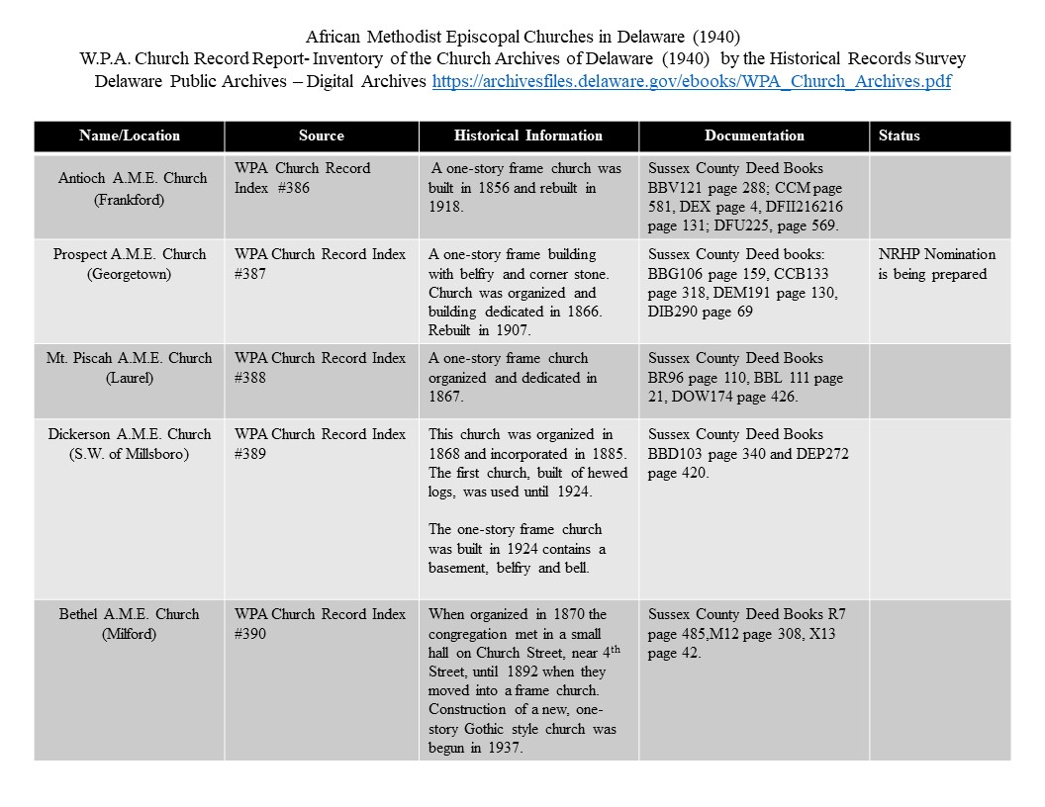

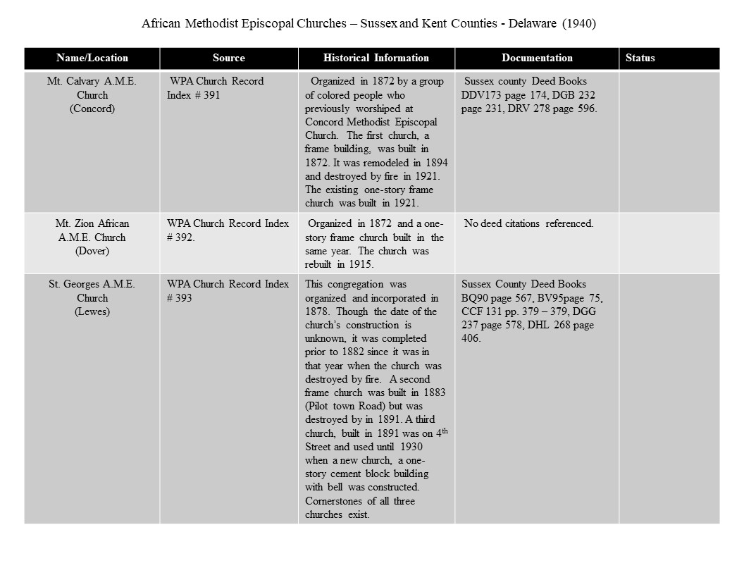

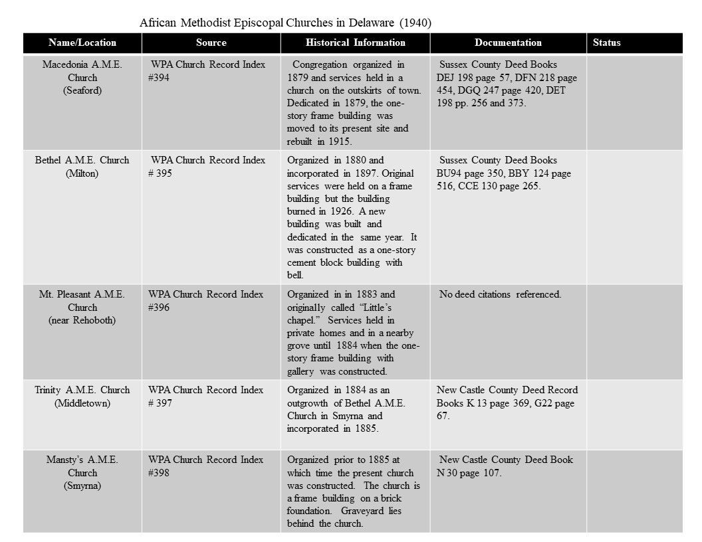

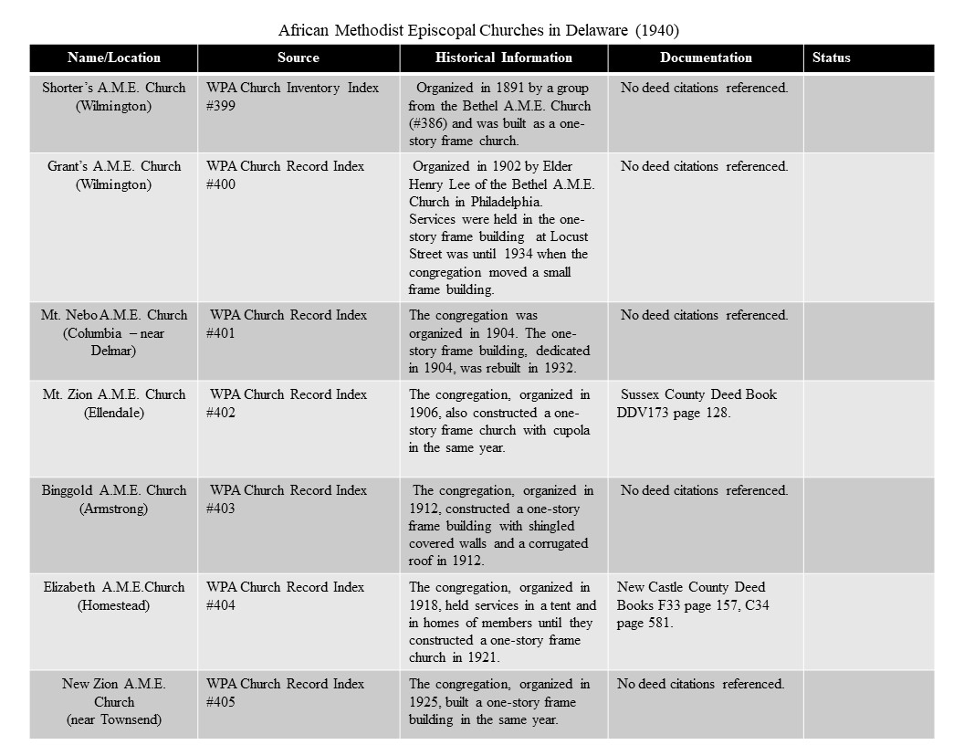
______________________________________________________________________________
- Major Bibliographical References

Bibliography (Cite the books, articles, and other sources used in preparing this form.)
Allen, Richard, The Life, Experience, and Gospel Labours of Rt. Rev. Richard Allen. Martin and Boden, Printers. Philadelphia, Pennsylvania.
Cape Gazette, (Lewes, Delaware) https://www.capegazette.com/
The Christian Recorder (Philadelphia, Pennsylvania), Accessible Archives.com.
Delaware Land Records, 1677-1947, online database, Provo, Utah. Ancestry.com.
Delaware Public Archives, Dover, Delaware.
Delaware Vital Records, 1800-1933, Ancestry.com
Downstate Delaware Genealogical Society. Tombstones of Sussex County Delaware Volume One. 1999.
Enduring Connections: Exploring Delmarva’s Black History, search engine, Nabb Research Center, Salisbury University, University of Maryland, enduringconnections.salisbury.edu.
General Assembly of Pennsylvania House Resolution No. 277 (1976).
George, Carol V.R. Segregated Sabbaths: Richard Allen and the Rise of Independent Black Churches, 1760-1840, NY: Oxford University Press, 1973.
Georgetown Historical Society, From Crossroads to County Seat: A Bicentennial Look at Georgetown, Delaware, ca. 1976.
Grey, Frank Arnold. New Railroad Map of the States of Maryland and Delaware and the District of Columbia, 1876.
Hancock, Harold. “William D. Yate’s Letter of 1837: Slavery and Colored People in Delaware,” Delaware History XIV (April 1971).
Jason, William C., Jr. The Delaware Annual Conference of the Methodist Church, 1864-1965. Dover, Delaware.
Laws of Delaware, Delaware Public Archives. Dover, Delaware. 1787.
McCabe Russell, Prospect A.M.E. Church Historic Marker file. Delaware Public Archives (Dover, Delaware).
McCabe, Russell, “Reverend Moses Robinson—Father of Prospect A.M.E Church,” 1996, unpublished essay located in Russell McCabe, Prospect A.M.E Church Historic Marker file.
The Milford Chronicle (Milford, DE)
Pomeroy and Beers Atlas of the State of Delaware. 1868.
Prospect A.M.E. Church Private Collections.
“Richard Allen (1760-1831): African Methodist Episcopal Founding Bishop,” Compass Points: Profiles & Biographies of African Americans from the Delmarva Peninsula, v. 1, Berlin, MD: Saltwater Media.
Richard Allen School – Georgetown, Delaware, NR# 100004083 (2019)
Sanborn Fire Insurance Map (1910, 1919).
Scharf, Thomas J. History of Delaware. Philadelphia, Pennsylvania. 1888.
Skelcher, Bradley. African American Education in Delaware: A History through Photographs, 1865-1930. Delaware Heritage Press, 1999.
Small, Clara, Compass Points: Profiles and Biographies of African Americans from the
Delmarva Peninsula, Berlin, MD: Salt Water Media, 2014.
Sussex County Recorder of the Deeds, Georgetown, Delaware.
The Christian Recorder, (Philadelphia, Pennsylvania) AccessableArchives.com.
The Milford Chronicle, (Milford, Delaware).
U.S. Federal Population Census. Ancestry.com.
Wade, William. 16 Miles from Anywhere. Georgetown, Delaware, 1975.
Williams, William H. “Black Preachers,” The Garden of American Methodism: The Delmarva Peninsula, 1769-1820.
Works Progress Administration Report, African Methodist Episcopal Churches in Delaware, Inventory of the Church Archives of Delaware, Historical Records Survey, 1940, Delaware Public Archives.
Zebley, Frank R. The Churches of Delaware. Wilmington, Delaware, 1947.

________________________________________________________________________
Previous documentation on file (NPS):

____ preliminary determination of individual listing (36 CFR 67) has been requested
____ previously listed in the National Register
____ previously determined eligible by the National Register
____ designated a National Historic Landmark
____ recorded by Historic American Buildings Survey #____________
____ recorded by Historic American Engineering Record # __________
____ recorded by Historic American Landscape Survey # ___________

Primary location of additional data:
_X _ State Historic Preservation Office
____ Other State agency
____ Federal agency
____ Local government
____ University
____ Other
Name of repository: _____________________________________

Historic Resources Survey Number (if assigned): __ S11395______________

______________________________________________________________________________
- Geographical Data

Acreage of Property _0.3556_Acre___________

Use either the UTM system or latitude/longitude coordinates

Latitude/Longitude Coordinates
Datum if other than WGS84:__________
(enter coordinates to 6 decimal places)
- Latitude: 38.690882 Longitude: -75.380277
- Latitude: Longitude:
- Latitude: Longitude:
- Latitude: Longitude:

Or
UTM References
Datum (indicated on USGS map):

NAD 1927 or NAD 1983

- Zone: Easting: Northing:
- Zone: Easting: Northing:
- Zone: Easting: Northing:
- Zone: Easting : Northing:

Verbal Boundary Description (Describe the boundaries of the property.)
The boundaries for Prospect A.M.E. Church follow the current Sussex County Tax Parcel number 135-15.17-164.00. The boundaries of the nominated property front Railroad Avenue, East Adam Street, a residential property, and private cemetery.

Boundary Justification (Explain why the boundaries were selected.)
The current Sussex County Tax Parcel boundaries includes portions of the original two acres conveyed to the Trustees of Prospect A.M.E. in 1840.

______________________________________________________________________________
- Form Prepared By

name/title: _Heidi Nasstrom-Evans (Principal Researcher) with the assistance of Rev. Janet Maull-Martin, Percell Parker, and members of Prospect A.M.E. Church_____________
organization: ___ Horizon Philanthropic _______________________________
street & number: _135 A, 1347 2nd Street _______________________________
city or town: __Lewes________________ state: __Delaware __ zip code:_19958______
e-mail_ hnasstromevans@horizonphilanthropic.com _______
telephone:__ (302) 644-0107 ___________________
date:__July 20, 2023__________________________

___________________________________________________________________________

Additional Documentation

Submit the following items with the completed form:

- Maps: A USGS map or equivalent (7.5- or 15-minute series) indicating the property's location.
- Sketch map for historic districts and properties having large acreage or numerous resources. Key all photographs to this map.

- Additional items: (Check with the SHPO, TPO, or FPO for any additional items.)

GEORGETOWN QUADRANGLE DELAWARE-SUSSEX CO. 7.5-MINUTE SERIES (2014) 38.69083811291118, -75.3802761644142
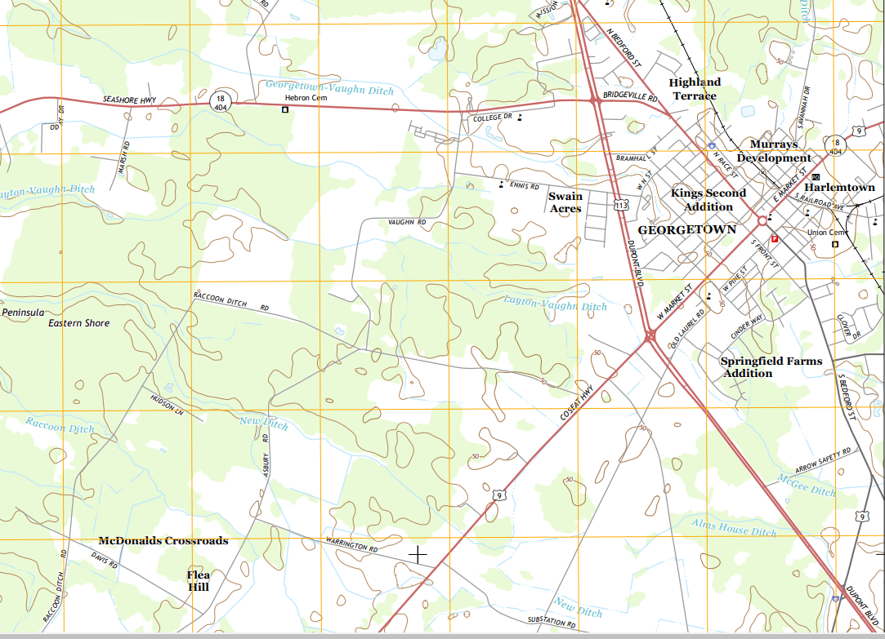

Photographs
Submit clear and descriptive photographs. The size of each image must be 1600x1200 pixels (minimum), 3000x2000 preferred, at 300 ppi (pixels per inch) or larger. Key all photographs to the sketch map. Each photograph must be numbered and that number must correspond to the photograph number on the photo log. For simplicity, the name of the photographer, photo date, etc. may be listed once on the photograph log and doesn’t need to be labeled on every photograph.

Photo Log

Name of Property: Prospect A.M.E. Church

City or Vicinity: Georgetown

County: Sussex State: Delaware

Photographer: Heidi Nasstrom-Evans

Date Photographed: July 17, 2023

Description of Photograph(s) and number, include description of view indicating direction of camera:

1 of 18 (DE_Sussex County_Prospect A.M.E. Church_001)
Façade view of church, looking south.

2 of 18 (DE_Sussex County_Prospect A.M.E. Church_002)
Environmental view of church and cemetery, looking south.

3 of 18 (DE_Sussex County_Prospect A.M.E. Church_003)
View of eastern elevation of church, looking west.

4 of 18 (DE_Sussex County_Prospect A.M.E. Church_004)
View of western elevation of church, looking east.

5 of 18 (DE_Sussex County_Prospect A.M.E. Church_005)
Rear of church with portion of cemetery, looking north.

6 of 18 (DE_Sussex County_Prospect A.M.E. Church_006)
Detailed view of doors located on the façade of the building, looking south.

7 of 18 (DE_Sussex County_Prospect A.M.E. Church_007)
Detailed view of cornerstones, located on the northwest corner of the building, looking south.
8 of 18 (DE_Sussex County_Prospect A.M.E. Church_008)
Environmental view of cemetery, looking south.

9 of 18 (DE_Sussex County_Prospect A.M.E. Church_009)
Detail view of cemetery, looking east.

10 of 18 (DE_Sussex County_Prospect A.M.E. Church_010)
Detail view of cemetery, looking east.

11 of 18 (DE_Sussex County_Prospect A.M.E. Church_011)
Detail view of cemetery, looking east.

12 of 18 (DE_Sussex County_Prospect A.M.E. Church_012)
Environmental view showing building’s close proximity to railroad tracks, looking northeast.

13 of 18 (DE_Sussex County_Prospect A.M.E. Church_013)
Interior view of sanctuary, looking south.

14 of 18 (DE_Sussex County_Prospect A.M.E. Church_014)
Detailed view of alter, looking south.

15 of 18 (DE_Sussex County_Prospect A.M.E. Church_015)
Detailed view of alter, looking south.

16 of 18 (DE_Sussex County_Prospect A.M.E. Church_016)
Interior view of sanctuary, looking north.

17 of 18 (DE_Sussex County_Prospect A.M.E. Church_017)
Detailed view of double doors leading from the vestibule to the sanctuary, looking south.

18 of 18 (DE_Sussex County_Prospect A.M.E. Church_018)
Detailed view of repurposed floor joists along the eastern wall of the sanctuary.

Photo Key:
Figures:
Figure 1: Pomeroy and Beers Atlas of the State of Delaware, 1868
Figure 2: Frank Arnold Grey – New Railroad Map of the States of Maryland and Delaware and the District of Columbia Excerpt, 1876
Figure 3: Map Excerpt: Georgetown, Delaware – 1885 Birds Eye View
Figure 4: Sanborn Fire Insurance Map Sampler (1910, 1919)
Figure 5: Photograph from Frank R. Zebley’s Churches of Delaware ca. 1936
Figure 6: 1956 Photo of Prospect A.M.E. Church
Figure 7: Sample of Obituaries of Individuals Associated with Prospect A.M.E. Church
Figure 8: Examples of church events at Prospect A.M.E. Church Published in the “Georgetown” Social Columns
Figure 9: Bicentennial of 1976 General Assembly of Pennsylvania House Resolution No. 277
Figure 10: Newspaper Excerpt from the Cape Gazette: Prospect A.M.E. Church’s Cornerstone (2014)

Paperwork Reduction Act Statement: This information is being collected for nominations to the National Register of Historic Places to nominate properties for listing or determine eligibility for listing, to list properties, and to amend existing listings. Response to this request is required to obtain a benefit in accordance with the National Historic Preservation Act, as amended (16 U.S.C.460 et seq.). We may not conduct or sponsor and you are not required to respond to a collection of information unless it displays a currently valid OMB control number.
Estimated Burden Statement: Public reporting burden for each response using this form is estimated to be between the Tier 1 and Tier 4 levels with the estimate of the time for each tier as follows:

Tier 1 – 60-100 hours
Tier 2 – 120 hours
Tier 3 – 230 hours
Tier 4 – 280 hours

The above estimates include time for reviewing instructions, gathering and maintaining data, and preparing and transmitting nominations. Send comments regarding these estimates or any other aspect of the requirement(s) to the Service Information Collection Clearance Officer, National Park Service, 1201 Oakridge Drive Fort Collins, CO 80525.

Henry J Evens, Jr., “Long history of Prospect A.M.E. Church Takes a Toll” Cape Gazette, January 16, 2014, http://cpg.stparchive.com/Archive/CPG/CPG01102014p52.php?tags=prospect|a.m.e.|church
Downstate Delaware Genealogical Society, Tombstones of Sussex County Delaware Volume One (1999), 225.
Sussex County Recorder of the Deeds, Georgetown, Delaware, Deed Book 49, pp.189-191.
Scharf, Thomas J. History of Delaware. Philadelphia, Pennsylvania, 1888, 1247.
1849 publication commemorating the 25th Philadelphia Annual Conference of the African Methodist Episcopal Church, Accessible Archives.com, 19.
Russ McCabe, “Rev. Moses Robinson—Father of Prospect AME Church,” 1996, unpublished essay located in Prospect A.M.E. Church Historic Marker file, Delaware Public Archives.
Russ McCabe, “Rev. Moses Robinson;” and Sussex County October Session 1839, p. 38 in Russ McCabe, Research File, Prospect AME Church Historic Marker, Delaware Public Archives.
1860 U.S. Federal Population Census. Ancestry.com.
1870 U.S. Federal Population Census. Ancestry.com.
1880 U.S. Federal Population Census. Ancestry.com.
Delaware Public Archives; Dover, Delaware; Delaware Vital Records, 1800-1933; Series Number: Death Records – 28 Henry Tingle August 6, 1887, Ancestry.com.
1850 U.S. Federal Population Census. Ancestry.com.
1860 U.S. Federal Population Census. Ancestry.com.
1870 U.S. Federal Population Census. Ancestry.com.
“Letter from Bishop Wayman” The Christian Recorder (Philadelphia, Pennsylvania) January 18, 1868, Accessible Archives.com.
Georgetown Historical Society, From Crossroads to County Seat: A Bicentennial Look at Georgetown, Delaware, ca. 1976, Page 82.
Sussex County Recorder of Deeds, Volume 106, Pages 159-160, Ancestry.com, Delaware, Land Records, 1677-1947 [database on-line], Provo, UT, USA.
“Rally Day,” The Milford Chronicle (Milford, Delaware) October 21, 1921.
1900 U.S. Federal Population Census. Ancestry.com.
1910 U.S. Federal Population Census. Ancestry.com.
William Wade, 16 Miles from Anywhere, Georgetown, Delaware, 38.
1870 U.S. Federal Population Census. Ancestry.com.
Scharf, Thomas J. History of Delaware, Philadelphia, Pennsylvania, 1888, 1247.
“Outrageous if True,” The North Star, October 20, 1848, in “African American Education in Georgetown,” Richard Allen School, Sussex County, DE, National Register of Historic Places Registration Form, 4/24/2019, Section 8, pages 13-15. The author of the Richard Allen School National Register form noted that The North Star was Frederick Douglass’ abolitionist newspaper.
“A Reply to ‘Thoughts on the subject of educating Negroes in the United States,’” American Watchman, September 4, 1816, in Bradley Skelcher, African American Education in Delaware: A History through Photographs, 1865-1930, Delaware Heritage Press, 1999, 3.
Harold Hancock, “William D. Yate’s Letter of 1837” Slavery and Colored People in Delaware,” Delaware History XIV (April 1971)8: 210 in Bradley Skelcher, 4.
Pauline Young, “The Negro in Delaware Past and Present,” in Delaware a History of the First State, V. II, ed. H. Clay Reed, NY: Lewis Historical Publishing Company, 1947, Page 586 in Skelcher, 11.
Significantly, 1866 is also a year after the end of the Civil War, which waged from 1861-1865. William Wade, Chapter VI, 1875-1900, 16 Miles from Anywhere: A History of Georgetown, Del., 52. In endnote 19, Wade cites his source for this information as Jacqueline Jones, The Delaware Association for the Moral Improvement and Education of Colored People (unpublished senior honors thesis, U. of Del., 1970), 72-73. Richard Allen School, National Register of Historic Places Registration Form, Section 8, p. 14, includes note #5 citing: “Date of construction noted in Frank Zebley’s, Churches of Delaware, self-published, 1947, 293, accessed via Delaware Public Archives, http://archives.delaware.gov/eBooks/ZebleyChurches.pdf, accessed August 10, 2017.”
William C. Jason, Jr., “The Delaware Annual Conference of the Methodist Church, 1864-1965,” in A Commemorative Booklet: Delaware Annual Conference, 1864-1965, Dover, DE: The United Methodist Church, Peninsula Annual Conference, Commission on Archives & History, and Delaware Conference History Committee, 1990, 40; Minutes of the Delaware Annual Conference of the Methodist Episcopal Church, 1866, at the Drew University Archives, Madison, NJ, in Bradley Skelcher, 10.
Carol V.R. George, Segregated Sabbaths: Richard Allen and the Rise of Independent Black Churches, 1760-1840, NY: Oxford University Press, 1973, 6.
“A Reply to ‘Thoughts on the subject of educating Negroes in the United States,” American Watchman, September 4, 1816, in Bradley Skelcher, 3.
“News from Georgetown, Del.” The Christian Recorder (Philadelphia, Pennsylvania) November 29, 1883, AccessableArchives.com.
Russ McCabe, “Rev. Moses Robinson—Father of Prospect AME Church,” unpublished essay, 1996, Prospect AME Church Historic Marker research file, Delaware Public Archives. “The transaction was officially registered within the office of the Recorder of Deeds on January 30, 1840,” in Georgetown Historical Society publication, 82. Handwritten notes on a photocopy of this page from the Prospect A.M.E. Church Historic Marker research file notes S.C. Deed; No. A49, p. 189, 1840.
Freedmen’s Bureau Acts of 1865 and 1866, United States Senate, https://www.senate.gov/artandhistory/history/common/generic/FreedmensBureau.htm#:~:text=On%20March%203%2C%201865%2C%20Congress,including%20newly%20freed%20African%20Americans, Accessed October 7, 2022.
Richard Allen School – Georgetown, Delaware, NR# 100004083 (2019), Section 8, page 13.
Richard Allen School – Georgetown, Delaware, NR# 100004083 (2019), Section 8, page 14, includes note #5 citing “The church’s parsonage was purchased from Hatfield in a deed that was dated December 12, 1885. Trustees for the region’s AME Churches identified in that deed included: Robert Wolford, Silas Little, Moses Drake, Wright Shuzels, Isaac Hall, George Wolford, John Short, William Ingram, Harris Ingram, Noah W. Moore, John J. Roberts, Riley Roberts, Abraham Ingram, and George. Ingram (Delaware Land Records, 1677-1947, Recorder of Deeds, Sussex County, RG 4555, Subgroup 000, Series 030, Delaware Public Archives, Dover, DE, Roll 83, v., 106, pp. 157-58),” and note #6 citing “The school was also referred to as Georgetown or as #12 in the Delaware records submitted to Bureau of Refugees, Freedmen and Abandoned Lands (The Freedman’s Bureau) by Samuel Woolman of the Delaware Association.
Minutes of the Acting Committee of the Delaware Association for the Moral Improvement and Education of the Colored People, June 1, 1867, Collection of the Delaware Historical Society, Wilmington, DE, in Richard Allen School, Section 8 page 14. Footnote 11, Section 8 page 15 states “Each teacher in each school in formerly slave states reported monthly to the Army’s Bureau of Refugees, Freedmen and Abandoned Lands during the years 1868-1872. Not all reports survive but many are available online through the website www.familysearch.org.”
Richard Allen School – Georgetown, Delaware, NR# 100004083 (2019), Section 8 p. 14.
Richard Allen School – Georgetown, Delaware, NR# 100004083 (2019), Section 8 p. 15.
Laws of Delaware, Delaware Public Archives, 1787.
William Wade, 16 Miles from Anywhere, Georgetown, Delaware, 38.
1870 U.S. Federal Population Census. Ancestry.com.
“Camp Meeting,” World Encyclopedia, newworldencyclopedia.org/entry/camp meeting; “The Story of Barratt’s Chapel,” Barratt’s Chapel & Museum website, barrattschapel.org/our-history.html.
Carol V.R. George, Segregated Sabbaths: Richard Allen and the Rise of Independent Black Churches, 1760-1840, NY: Oxford University Press, 1973, p. 6
Richard Allen, The Life, Experience, and Gospel Labours of Rt. Rev. Richard Allen . . . With an Address to the People of Colour of the United States, Philadelphia: Martin and Boden, Printers, 1833, p. 3 in Clara L. Small, “Richard Allen (1760-1831): African Methodist Episcopal Founding Bishop,” Compass Points: Profiles & Biographies of African Americans from the Delmarva Peninsula, v. 1, Berlin, MD: Salt Water Media, 2-14, 147.
William H. Williams, “Black Preachers,” The Garden of American Methodism: The Delmarva Peninsula, 1769-1820, The Peninsula Conference of the United Methodist Church, 1984, p. 145; Clara L. Small, “Richard Allen (1760-1831): African Methodist Episcopal Founding Bishop.”
William Williams, “Black Preachers,” 145.
Richard Allen School – Georgetown, Delaware, NR# 100004083 (2019), Section 8 p. 22.
Ryan Mavity, “Milton honors Bryan Stevenson. Social justice activist: I am the product of hope,” Cape Gazette, October 11, 2022.
A Brief History of the Christian Recorder https://www.thechristianrecorder.com/history/.

